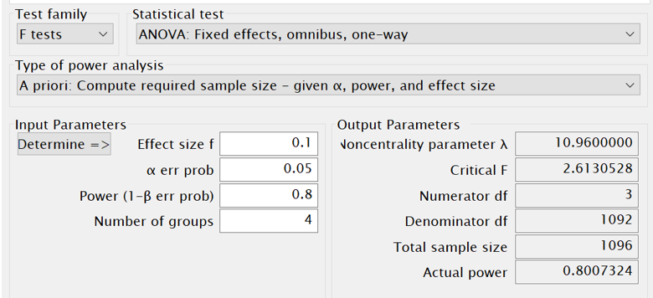

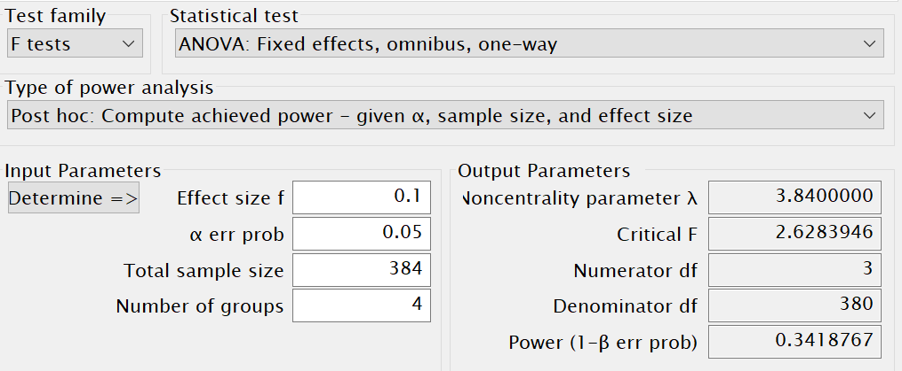

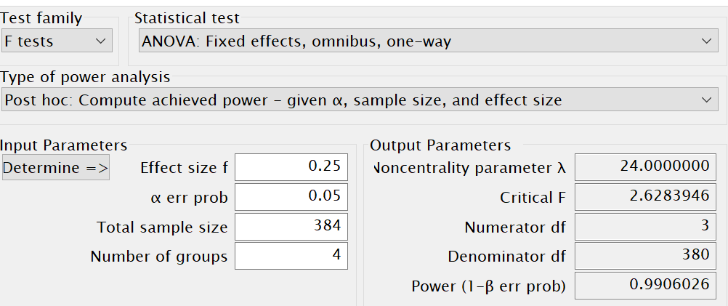

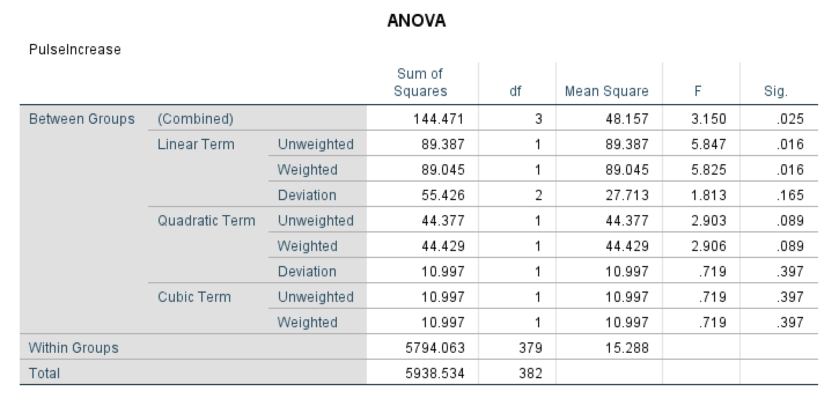

• Compute (semipartial) eta-squared and place a 90% confidence interval about it.  [Why 90%?](http://core.ecu.edu/psyc/wuenschk/docs30/CI-Eta2-Alpha.doc)

• Conduct pairwise comparisons using the REGWQ procedure. Hold familywise alpha at a maximum of .05.

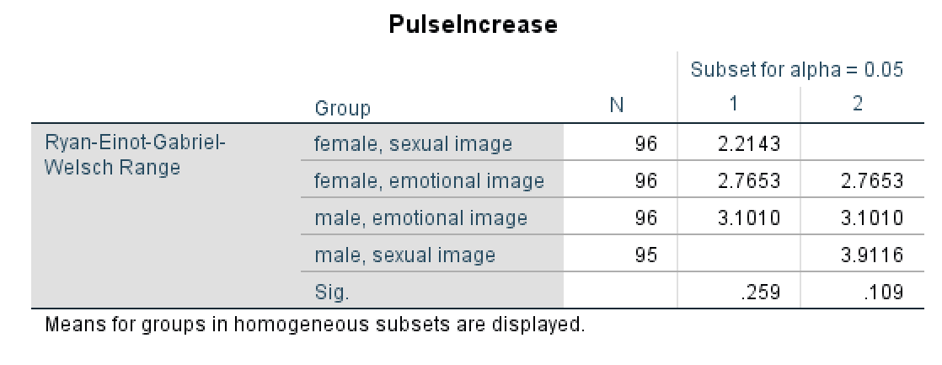

Mean pulse rate change was significantly higher in the male, sexual group than in the female, sexual group. Difference between Male, Sexual group pulse rate change and Both emotional groups fell short of statistical significance.

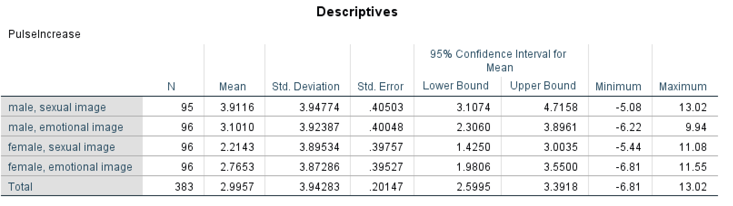

• In a separate document, all of the statistical output.  Name this document **"Nnnnn_Output" where "Nnnnn" is your last name**

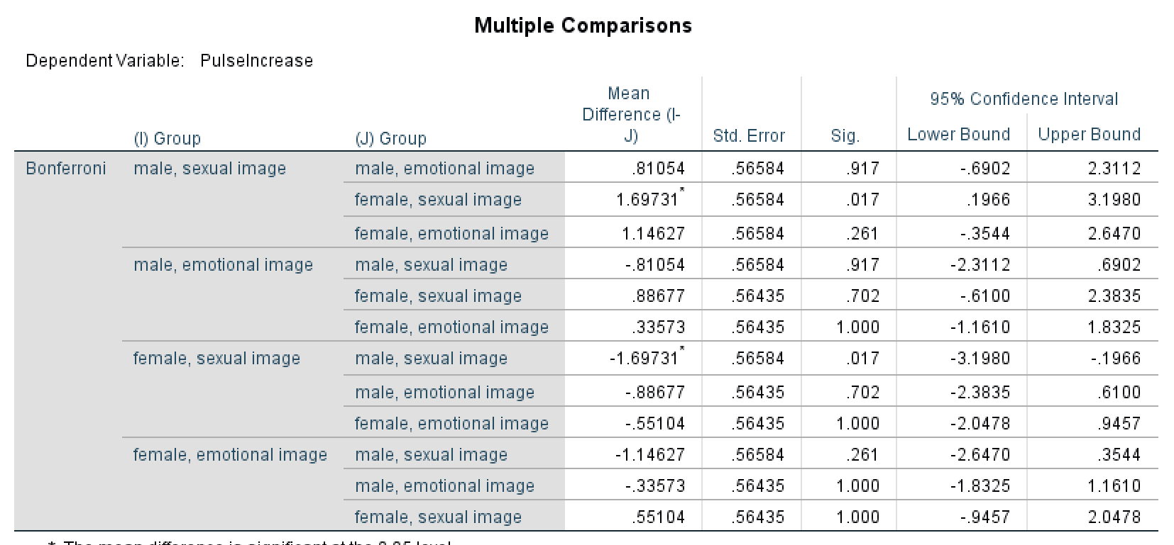

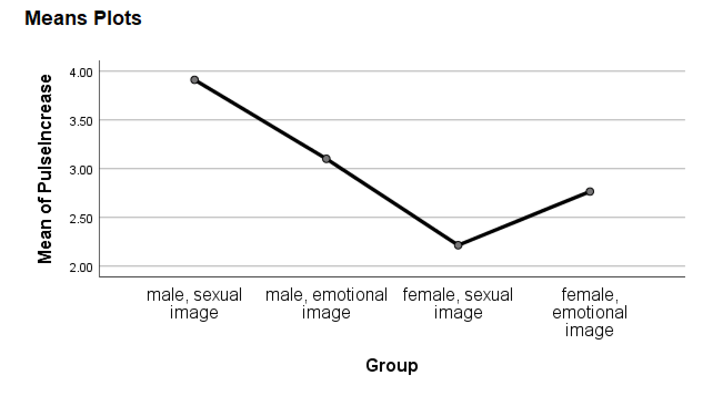

Attach both documents to a piece of [**email sent to me**](mailto:WuenschK@ECU.edu?subject=PSYC%207431:%20%20ANOVA_REGWQ%20Homework) with the subject line "**PSYC 7431:  ANOVA_REGWQ Homework**."